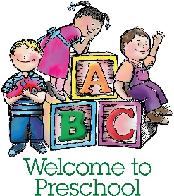
What You Will Need for the First Day of School
- 1 COMPLETE set of WEATHER APPROPRIATE extra clothes to keep at school. (Shirt, pants, underwear, socks)
- 1 small blanket and sheet for nap time (crib sheet size) – NO PILLOWS or STUFFED ANIMALS
- 1 Backpack large enough to fit jackets, hats, gloves, etc

Please do NOT bring:
- Food/Drinks/Snacks
- Toys from home, (including Stuffed Animals)
- Chapstick/Lip Gloss/Makeup/Lotions
- Medications – unless with appropriate forms from Dr. and School District

Healthy Habits for your Child to be Ready for the SchoolDay
- Pick out clothes/shoes the night before
- Make and enforce and healthy bed TIME & Routine (according to the sleepfoundation.org, preschool aged children should get between 11-13 hours of sleep a night)
- Wake up with enough time to get ready
- Eat a healthy (non-sugary) breakfast
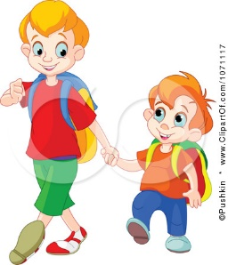
- Minimize “screen time” (tv’s, tablets, phones, etc) before school
- Kindly discuss goals/accomplishments/ideas for the day or from the night before

